**Lab Problem: 05.**  


**Course code: CCE-312.**

**Course Title: Numerical Methods sessional.**

**Remarks & Signature:**

**Name of the Lab Report:** Solve Real world problem and Simul equation using Cramer’s rule after that implement it by Python.

**Submitted To**

**Professor Dr. Md. Samsuzzaman.**

**Professor,**

**Department of Computer and Communication Engineering.**

**Faculty of Computer Science & Engineering.**

**Submitted By**

**HASAN AHAMMAD**

**ID No: 1902073**

**Reg No: 08779**

**Level- 3, Semester- 1**

**Session: 2019-2020**

**Faculty of Computer Science & Engineering.**

**Patuakhali Science & Technology University.**

**Dumki, Patuakhali-8602.**

1. **A total of 8,500 taka was invested in three interest earning accounts. The interest rates were 2%,3% and 6% if the total simple interest for one year was 380 taka and the amount invested at 6% was equal to the sum of the amounts in the other two accounts, then how much was invested in each account? (Use Cramer’s rule) and implement with python.**

Let the amounts invested in the three accounts be Tk. x, Tk. y and Tk. z

Interest for the three accounts are (2/100)x, (3/100)y and (6/100)z

According to the problem,

x + y + z = 8500 ……..…………………………………………… (1)

(2/100)x + (3/100)y + (6/100)z (or) multiplying by 100,

2x + 3y + 6z = 38000 ……………………………………………. (2)

z = x + y or x + y - z = 0............................................. (3)

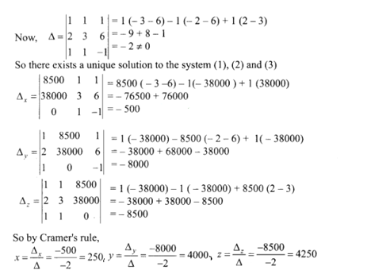

Thus the amount invested at 2% is Tk. 250, at 3% is Tk. 4000 and at 6% is Tk. 4250.

* **Implement using Python:**
* import numpy as np  
    
  coefficients = np.array([[1, 1, 1],  
   [2, 3, 6],  
   [1, 1, -1]])  
    
  constants = np.array([8500, 38000, 0])  
    
  det_coefficients = np.linalg.det(coefficients)  
    
    
  coefficients_x = coefficients.copy()  
  coefficients_x[:, 0] = constants  
    
  coefficients_y = coefficients.copy()  
  coefficients_y[:, 1] = constants  
    
  coefficients_z = coefficients.copy()  
  coefficients_z[:, 2] = constants  
    
    
  det_x = np.linalg.det(coefficients_x)  
  det_y = np.linalg.det(coefficients_y)  
  det_z = np.linalg.det(coefficients_z)  
    
    
  solution_x = det_x / det_coefficients  
  solution_y = det_y / det_coefficients  
  solution_z = det_z / det_coefficients  
    
  print("Solution:")  
  print(f"x = {solution_x}")  
  print(f"y = {solution_y}")  
  print(f"z = {solution_z}")
* Using Cramer's rule solve the following after that implement it using Python.

.3x1+.52x2+x3=0.01

.5x1+.3x2+.5x3=.67

.1x1+.3x2+.5x3=-.44

**Soln:** Let us write these equations in the form AX=B

$\left[\begin{matrix}.3 & .52 & 1 \\ .5 & .3 & .5 \\ .1 & .3 & .5\end{matrix}\right]\left[\begin{matrix}x_{1} \\ x_{2} \\ x_{3}\end{matrix}\right]=\left[\begin{matrix}.01 \\ .67 \\ -.44\end{matrix}\right]$

D=|A|==.3(.5x.3-.5x.3)-.52(.5x.5-.5x.1)+1(.5x.3-.3x.1)=0.016

Dx1==0.0444

Dx2== -0.1255

=0.05054

X1= Dx1/D=0.0444/0.016=2.775

X2= Dx2/D=-0.1255/0.016=-7.84375

X3=/D=0.05054/0.016=3.158

* **Implement using python:**
* import numpy as np  
  coefficients = np.array([[0.3, 0.52, 1],  
   [0.5, 0.3, 0.5],  
   [0.1, 0.3, 0.5]])  
    
  constants = np.array([0.01, 0.67, -0.44])  
    
  det_coefficients = np.linalg.det(coefficients)  
    
  coefficients_x = coefficients.copy()  
  coefficients_x[:, 0] = constants  
    
  coefficients_y = coefficients.copy()  
  coefficients_y[:, 1] = constants  
    
  coefficients_z = coefficients.copy()  
  coefficients_z[:, 2] = constants  
    
  det_x = np.linalg.det(coefficients_x)  
  det_y = np.linalg.det(coefficients_y)  
  det_z = np.linalg.det(coefficients_z)  
    
    
  solution_x = det_x / det_coefficients  
  solution_y = det_y / det_coefficients  
  solution_z = det_z / det_coefficients  
    
  print("Solution:")  
  print(f"x = {solution_x}")  
  print(f"y = {solution_y}")  
  print(f"z = {solution_z}")